GERMAN INSTITUTE OF BUSINESS AND TECHNOLOGY

AZUBI AFRICA GRADUATE PROGRAMME

DATA SCIENCE TRACK

**THE EFFECT OF COVID – 19 ON TRADE**

By

BENEDICT NARTEY

IBRAHIM ADAM

MAAME ODURO YEBOAH

Mentored by

AUDREY MENGUE

SEPTEMBER, 2020

# **DECLARATION**

We hereby declare that except for specific references, citations and quotations which have been properly acknowledged, this work is the result of our own research and has not been submitted in part or whole elsewhere.

Signature …………………………………. Date ……………………………….

Benedict Nartey (Candidate)

Signature …………………………………. Date ……………………………….

Ibrahim Adam (Candidate)

Signature …………………………………. Date ……………………………….

Maame Oduro Yeboah (Candidate)

Signature …………………………………... Date …………………………………

Audrey Mengue (Mentor)

# **ABSTRACT**

With rapid increase in motorization, urbanization, population growth, and changes in population density, importation and exportation have increased worldwide. Even before COVID-19, globalization was already under significant threat from rising nationalism forcing governments and businesses to define new constructs and priorities [1]. This response to the conflicting forces of globalization and nationalism has given rise to the term “slowbalization”, coined by *The Economist* to describe declines in trade, multinational profits, and foreign investment and leading to arguments that we have now passed ‘peak globalisation’. The COVID-19 pandemic appears to have introduced additional fear and uncertainty among populations, resulting in new behaviours and beliefs [2]. People are becoming more suspicious and less accepting of foreign things and all this is occurring on a background of increasing anarchy in global governance [2].

While governments across the world are putting in place all measures to contain, minimize and even halt the spread of COVID-19 due to several reasons and some of which include the unavailability of health facilities, how would these countries successfully limit the transmission of COVID-19 while also providing economic relief to families and businesses affected by **social** distancing or ‘lockdown’ strategies?

The aim of our project is to examine the effect COVID-19 is having on the trade, that is imports and exports looking at the revenues from previous trades and how it fared during the pandemic period. This will help us to know the channels and commodities which has, was and is still being affected by the Coronavirus and how to put measures in place to mitigate it.

**CONTENTS**

**DECLARATION** 2

**ABSTRACT** 3

**CHAPTER 1** 6

**INTRODUCTION** 6

**1.1** **General Background** 7

**1.2 Problem Statement** 8

**1.3 Coronavirus disease (COVID-19)** 8

**1.4 Trade impacts from COVID-19** 9

**1.5 Importing countries' resources impacted by COVID-19 cases** 10

**1.6 Research Objectives** 10

**1.6.1 General Objective** 10

**1.6.2 Specific objectives** 11

**1.7 Hypothesis** 11

**CHAPTER 2** 12

**LITERATURE REVIEW** 12

**2.1 Introduction** 12

**2.1.1 Profile of New Zealand** 12

**Profile of Ghana** 13

**CHAPTER 3** 14

**METHODOLOGY** 14

**3.1 Introduction** 14

**3.2 Data Overview** 14

**3.3 Tools** 15

**3.4 Exploratory Data Analysis** 15

**3.5 Quantitative Analysis** 16

**3.6 Qualitative Analysis** 16

**3.7 Questions Asked** 16

**CHAPTER 4** 17

**ANALYSIS** 17

**CHAPTER 5** 20

**CONCLUSION AND RECOMMENDATIONS** 20

**4.1 Conclusion** 20

**4.2 Recommended Solutions** 20

**REFERENCES** 21

# **CHAPTER 1**

# **INTRODUCTION**

After years of growth for world trade, global tourism and international cooperation, globalization hit a couple of roadblocks in recent years After global trade growth slowed significantly in 2019, due to large part to trade tensions between the United States and China, the COVID-19 pandemic is expected to cause an unprecedented fall in world trade.

According to estimates from the World Trade Organization, world merchandise trade is set to plummet between 13 and 32 percent this year, depending on how quickly the coronavirus is contained and trade can return to pre-crisis levels [3]. A press release sometime this year by the World Trade Director stated that these numbers were not at all impressive and there is no way one could get around that unless a rapid, vigorous rebound was made possible while emphasizing the role of free trade on the road to recovery. He also added that, “Keeping markets open and predictable, as well as fostering a more generally favourable business environment, will be critical to spur the renewed investment we will need. And if countries work together, we will see a much faster recovery than if each country acts alone [3]."

The COVID-19 pandemic is putting global supply chains under intense pressure and disrupting trade. According to a publication on the website of the New foreign affairs and trade, “New Zealand is working with our trading partners to help ensure that trade continues to flow unimpeded, to remove any existing trade restrictive measures on essential goods, especially medical supplies, to protect supply chains and to keep critical infrastructure such as air and seaports open.”

## **General Background**

Besides its worrying effects on human life, the COVID-19 pandemic represents an unprecedented chaos to the global economy and world trade, as production and consumption are scaled back across the globe [4].

The rapid spread of COVID-19 and the measures taken by various governments to contain it have had serious consequences for the world’s major economies. Many productive activities have been disrupted, first in Asia and then in Europe, North America and the rest of the world, and there have been widespread border closures everywhere. This has led in a steep rise in unemployment, especially in the United States, with a consequent reduction in demand for goods and services. Against this backdrop, the global GDP in 2020 is expected to register its sharpest contraction since the Second World War. In this situation, the volume of global trade in goods fell by 17.7% in May 2020 compared with the same month in 2019.

The drop in the first five months of the year was widespread, although it particularly affected exports from the United States, Japan, and the European Union. The economic contraction in China was smaller than the global average, as that country controlled the outbreak and reopened its economy relatively quickly. Latin America and the Caribbean are the most affected developing regions.

In a global context of increased production regionalization, regional integration must play a key role in the crisis-recovery strategies in Latin America and the Caribbean. To move forward with regional integration, infrastructure and logistics must be included in economic recovery packages. In addition to their sizeable direct contributions to GDP and employment, infrastructure and logistics are essential for the production of all goods and services, the supply of food and essential services, and international trade competitiveness.

## **1.2 Problem Statement**

Most countries do not produce all the goods they consume, likewise they do not consume all the goods that they produce. Hence most economies depend on each other to supplement the goods they need in their economies. This is the main reason for import and exports aside other benefits like income, reliefs and supports for partner countries in times of need.

New Zealand engages in import and export of some commodities to different countries in different continents so as to supplement its production and also earn something from its exportation to those countries. The commodities they engage in include;

* Diary
* Forestry
* Fruits
* Machinery and electronics
* Meat
* Non-foods manufacturing
* Seafood

## **1.3 Coronavirus disease (COVID-19)**

According to the World Health Organization, WHO, “COVID-19 is the infectious disease caused by the most recently discovered coronavirus. This new virus and disease were unknown before the outbreak began in Wuhan, China, in December 2019. COVID-19 is now a pandemic affecting many countries globally [5].”

The outbreak of COVID-19 late 2019 affected trading in the country due to the closure of boarders and less engagements and participation among countries New Zealand trade with. Due to this we are looking at the past experience of trade and comparing it to current time in order to establish how trade has been affected by COVID-19 as it is still affecting most economies [5].

## **1.4 Trade impacts from COVID-19**

The Ministry for Primary Industries (MPI), the Ministry of Foreign Affairs and Trade (MFAT), and New Zealand Trade & Enterprise (NZTE) continue to monitor how COVID-19 is affecting New Zealand primary industries and businesses.New Zealand businesses have experienced major disruptions as a result of COVID-19, including those businesses in offshore markets. Disruptions experienced by our exporters have had flow-on effects to the domestic economy.

There are no formal restrictions on market access for the vast majority of goods exports and imports as a result of COVID-19 but the global pandemic continues to place pressure on global supply chains and is disrupting trade flows and the wider international economy.

Primary industry exporters continue to experience a level of disruption to their trade in a number of markets due to issues related to delays in ports and the wider global transport network.

There have been some improvements in the flow of freight as restrictions begin to be lifted and business activity picks up however, MPI, MFAT, and NZTE are continuously monitoring developments to look for ways they can provide support to our exporters during this unprecedented event.

## **1.5 Importing countries' resources impacted by COVID-19 cases**

There is ongoing international concern related to reports of ports that have been impacted with logistical delays such as reduced storage and inspection facilities due to the impact of COVID-19. Disrupted courier services are also causing problems for exporters where consignments are diverted to other ports for disembarkation and the documentation needs to be replaced. While the lifting of restrictions may alleviate this, the situation remains uncertain and may change quickly.

MPI recommends that exporters stay in close contact with importers when planning and tracking exports as they will have the most up-to-date information on any logistical issues in the region.

MPI is continually looking for ways we can work with our overseas counterparts to facilitate the clearance of New Zealand products into export markets that are experiencing COVID-19 related difficulties. Our work has included setting up or progressing processes for paperless certification and making arrangements to expedite clearances with our trading partners.

## **1.6 Research Objectives**

### **1.6.1 General Objective**

The aim of our project is to examine the effect COVID-19 has on trade, which is imports and exports, looking at the revenues from previous trades and how it fared during the pandemic period. This will help us to know the channels and commodities which has, was and is still being affected by the Coronavirus and how to put measures in place to mitigate it.

### **1.6.2 Specific objectives**

* To analyse the global effect of COVID-19 on trade in New Zealand.
* To establish the trends of trade before and during the pandemic and make predictions on subsequent trades.
* To establish a relationship between New Zealand and the trade partners and how the pandemic affected their trade
* To know the commodities that were in demand during the pandemic and capitalise on their importation or exportation.
* To be able to establish how other countries like Ghana can take advantage of the effects on trade to import or export some commodities to New Zealand.

## **1.7 Hypothesis**

* Trades were ongoing during the pandemic period New Zealand.
* The pandemic did not affect trade in New Zealand.
* The various partner countries were opened for trade.
* There was increase in revenues from the trades of the various commodities.
* The amount of exports and import increases with time before and during the pandemic period.

# **CHAPTER 2**

# **LITERATURE REVIEW**

## **2.1 Introduction**

### **2.1.1 Profile of New Zealand**

New Zealand [island country](https://en.wikipedia.org/wiki/Island_country) in the southwestern [Pacific Ocean](https://en.wikipedia.org/wiki/Pacific_Ocean). It comprises two main landmasses; the [North Island](https://en.wikipedia.org/wiki/North_Island) and the [South Island](https://en.wikipedia.org/wiki/South_Island) and around 600 [smaller islands](https://en.wikipedia.org/wiki/List_of_islands_of_New_Zealand), covering a total area of 268,021 square kilometers. New Zealand is about 2,000 kilometers east of [Australia](https://en.wikipedia.org/wiki/Australia) across the [Tasman Sea](https://en.wikipedia.org/wiki/Tasman_Sea) and 1,000 kilometers south of the islands of [New Caledonia](https://en.wikipedia.org/wiki/New_Caledonia), [Fiji](https://en.wikipedia.org/wiki/Fiji), and [Tonga](https://en.wikipedia.org/wiki/Tonga). New Zealand's [capital city](https://en.wikipedia.org/wiki/Capital_of_New_Zealand) is [**Wellington**](https://en.wikipedia.org/wiki/Wellington), and its most populous city is [Auckland](https://en.wikipedia.org/wiki/Auckland). English is the official language while their currency is the New Zealand dollar (NZD)

With an estimated population of about five million as at September 2020, New Zealand is considered as one of the developed countries  which [ranks highly](https://en.wikipedia.org/wiki/International_rankings_of_New_Zealand) in international comparisons of national performance, such as quality of life, education, protection of [civil liberties](https://en.wikipedia.org/wiki/Civil_liberties), government transparency, and [economic freedom](https://en.wikipedia.org/wiki/Economic_freedom). The country underwent [major economic changes](https://en.wikipedia.org/wiki/Rogernomics) during the 1980s, which transformed it from a [protectionist](https://en.wikipedia.org/wiki/Protectionist) to a [liberalized](https://en.wikipedia.org/wiki/Economic_liberalization) [free-trade](https://en.wikipedia.org/wiki/Free-trade) economy. Among the main partners of New Zealand as at June 2018, are China (NZD27.8 billions), Australia (NZD26.2 billions), the [European Union](https://en.wikipedia.org/wiki/European_Union) (NZD22.9 billions), the United States (NZD17.6 billions), and Japan (NZD8.4 billions) [6].

New Zealand is heavily dependent on international trade, particularly in agricultural products. Exports account for 24% of its output, making New Zealand vulnerable to international commodity prices and global [economic slowdowns](https://en.wikipedia.org/wiki/Recession). Food products made up 55% of the value of all the country's exports in 2014; wood was the second largest earner (7%).On 7 April 2008, New Zealand and China signed the [New Zealand–China Free Trade Agreement](https://en.wikipedia.org/wiki/New_Zealand%E2%80%93China_Free_Trade_Agreement), the first such agreement China has signed with a developed country. The service sector is the largest sector in the economy, followed by manufacturing and construction and then farming and raw material extraction [6].

### **Profile of Ghana**

Officially the Republic of Ghana is a country along the [Gulf of Guinea](https://en.wikipedia.org/wiki/Gulf_of_Guinea) and the [Atlantic Ocean](https://en.wikipedia.org/wiki/Atlantic_Ocean), in the [sub region](https://en.wikipedia.org/wiki/Subregion) of [West Africa](https://en.wikipedia.org/wiki/West_Africa). Spanning a [land mass](https://en.wikipedia.org/wiki/Land_mass) of 238,535 km2 , Ghana is bordered by the [Ivory Coast](https://en.wikipedia.org/wiki/Ivory_Coast) in [the west](https://en.wikipedia.org/wiki/Ghana%E2%80%93Ivory_Coast_border), [Burkina Faso](https://en.wikipedia.org/wiki/Burkina_Faso) in [the north](https://en.wikipedia.org/wiki/Burkina_Faso%E2%80%93Ghana_border), [Togo](https://en.wikipedia.org/wiki/Togo) in [the east](https://en.wikipedia.org/wiki/Ghana%E2%80%93Togo_border), and the [Gulf of Guinea](https://en.wikipedia.org/wiki/Gulf_of_Guinea) and Atlantic Ocean in the south. Ghana means "Warrior King" in the [Soninke language](https://en.wikipedia.org/wiki/Soninke_language).

Ghana is the 70th largest export economy in the world and the 111th most complex economy according to the Economic Complexity Index (ECI). In 2017, Ghana exported $17.1B and imported $13.2B, resulting in a positive trade balance of $3.9B. In 2017 the GDP of Ghana was $59B and its GDP per capita was $4.49k.

The top exports of Ghana are [Gold](https://legacy.oec.world/en/profile/hs92/7108/)($8.35B), [Crude Petroleum](https://legacy.oec.world/en/profile/hs92/2709/)($2.97B), [Cocoa Beans](https://legacy.oec.world/en/profile/hs92/1801/) ($1.77B), [Cocoa Paste](https://legacy.oec.world/en/profile/hs92/1803/) ($538M) and [Coconuts, Brazil Nuts, and Cashews](https://legacy.oec.world/en/profile/hs92/0801/) ($325M), using the 1992 revision of the HS (Harmonized System) classification. Its top imports are [Cars](https://legacy.oec.world/en/profile/hs92/8703/) ($793M), [Delivery Trucks](https://legacy.oec.world/en/profile/hs92/8704/) ($442M), [Refined Petroleum](https://legacy.oec.world/en/profile/hs92/2710/) ($415M), [Rice](https://legacy.oec.world/en/profile/hs92/1006/) ($369M) and [Non-fillet Frozen Fish](https://legacy.oec.world/en/profile/hs92/0303/) ($278M).

The top export destinations of Ghana are India ($5.09B), China ($1.9B), Switzerland ($1.84B), South Africa ($918M) and the Netherlands ($911M). The top import origins are China ($3.08B), the United States ($1.1B), India ($660M), Belgium-Luxembourg($637M) and the United Kingdom($587M).

# **CHAPTER 3**

# **METHODOLOGY**

## **3.1 Introduction**

This chapter presents the rules and steps involved in the Exploratory Data Analysis (EDA). A complete and accurate description of the tools and techniques used in the building of this project will be discussed. This chapter also entails the mode of sample and data collection, as well as every structure for the making of this project. From Section 3.4 through to 3.6, the prescribed steps to our EDA, the system analysis and finally, the stages of the methodology are discussed respectively.

## **3.2 Data Overview**

The dataset was obtained from the Stats NZ Tatauranga Aotearoa, New Zealand's official data agency. The data was collected form 1st February 2015 to August 2020. It contains records of daily trade values in terms of revenues generated and quantity in tones for commodities imported to partner countries.

From a profiling report generated from Jupyter notebook, the dataset contains 511896 entries consisting of 46536 rows and 11 columns. The different data types in the datasets were numeric and categorical.

The column label are as follows;

* Direction: this provides information on whether the trade involved was an import, export or a reimportation of commodities.
* Year: This indicates the year in which the trade occurred, 2015 to 2020.
* Date: The date the trade took place.
* Weekday: The associated weekday the trade took place, that is Monday, Tuesday, Wednesday, Thursday, Friday. Saturday or Sunday.
* Current_Match: This variable compares the trades dates in the previous years that is 2015, 2016, 2017, 2018 and 2019 to the current year dates, which is 2020.
* Country: The list of countries involved in trade with New Zealand. They are Australia, China, East Asia countries excluding China, European Union, Japan, United Kingdom, United States and All countries excluding China (Total excluding china) and All countries.
* Commodity: all the commodities traded by New Zealand.
* Transport: This variable indicates the mode of transportation which includes air, Sea or both.
* Measure: the unit in which the trade was measured, either NZD or tonnes.
* Values: the revenues generated
* Cumulative: the continuous sum of the revenues

## **3.3 Tools**

* Python programming language.
* Jupyter Notebook
* Excel for data manipulation.
* Microsoft Power BI

## **3.4 Exploratory Data Analysis**

Exploratory Data Analysis (EDA) is a technique for analysing datasets in order to obtain the summary and descriptive statistics of the main characteristics of the dataset [7]. Most of these features are obtained using visual that were obtained from our analysis in Jupyter Notebook, Microsoft Excel and Power BI. Exploratory Data Analysis (EDA) is used on the other hand to answer questions, test assumptions, and generate hypothesis for further analysis. The processes involved in EDA include;

* Cleaning the data by looking out for missing or null values.
* Removing row or column that are not needed or relevant to the analysis.
* Visualizing data distribution using various methods like bar charts, histograms, pie charts, etc.

## **3.5 Quantitative Analysis**

The data was manipulated and well explored to check for missing values, null values, the number of columns and rows. Further exploration was done to obtain the statistics of various column variable. Further analysis of the data was done with python programming language (Version 3.8) in Jupyter notebook and Power BI.

## **3.6 Qualitative Analysis**

The dataset was analyzed to see trends and patterns of how the various commodities were performing in previous years and during the pandemic period. This helped us to gain deeper understanding of the various categorical variables. The graphs and visualizations obtained showed the patterns of the trends and conclusions made.

## **3.7 Questions Asked**

* What are the commodities traded by New Zealand?
* Which commodity or commodities are generated higher revenues?
* What is the trend of revenues generated from year to year?
* What are the commodities that are exported from New Zealand?
* What are the commodities imported to New Zealand?
* Which countries are involved in the trade with New Zealand?
* Which countries does New Zealand import commodities from?
* What are the countries New Zealand export commodities to?
* How was the trend of trade between partners prior to COVID-19 and during COVID-19?
* Is the change in trend as a result of COVID-19?

# **CHAPTER 4**

# **ANALYSIS**

**Table 1: Summary of Imports and Exports from 2015 to 2020**

|  |  |  |  |  |  |
| --- | --- | --- | --- | --- | --- |
| Year | Total Export | Total Import | Non-food manufactured goods | Others (imports) | Percentage (%) Increase/Decrease  (Imports) |
| 2015 | 27,293,000,000 | 20,828,000,000 | 20,228,000,000 | 600,000,000 |  |
| 2016 | 27,042,000,000 | 20,018,000,000 | 20,380,000,000 | 362,000,000 | -3.89 |
| 2017 | 29,017,000,000 | 22,098,000,000 | 21,557,000,000 | 541,000,000 | 10.39 |
| 2018 | 31,281,000,000 | 25277000000 | 23,656,000,000 | 1,621,000,000 | 14.39 |
| 2019 | 33,069,000,000 | 25368000000 | 24,206,000,000 | 1,162,000,000 | 0.36 |
| 2020 | 33,235,000,000 | 22247000000 | 21,252,000,000 | 995,000,000 | -12.3 |

From the table given above, it can be seen that exports in New Zealand have been rising since 2016. There was a peak at 2019 which flattened in the year 2020. A major contribution to this flattening was due to the global pandemic which shut most economies down over two whole months. Now, New Zealand was still able to export goods because their major market was China which were able to control the pandemic and limit the spread of the virus in one province. Hence, the rest of China was still open to market.

Also from figure 2 below, New Zealand export to and import from almost all the continents of the world. They Export largely to North America and Asia. Their trade with China was the largest in Asia. The revenues for from trade over the past five years show a gradual increase with time. However, imports in late 2019 to early 2020 shows a decline with are due to the novel corona virus pandemic. Likewise, there was a drop in exports as well although they were still able to export to some countries like China who were able to contain the spread of the virus quite early enough.

From figure 3 give a breakdown of the various commodities traded over the past five years. Diary and meat top the chart while forestry, non-food manufactured goods and seafood follow up. The least traded commodity is fruits.

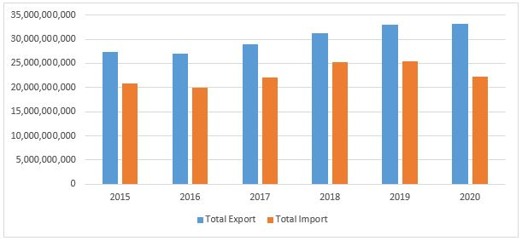

**Figure 1: Total export and import of goods from 2015 to 2020**

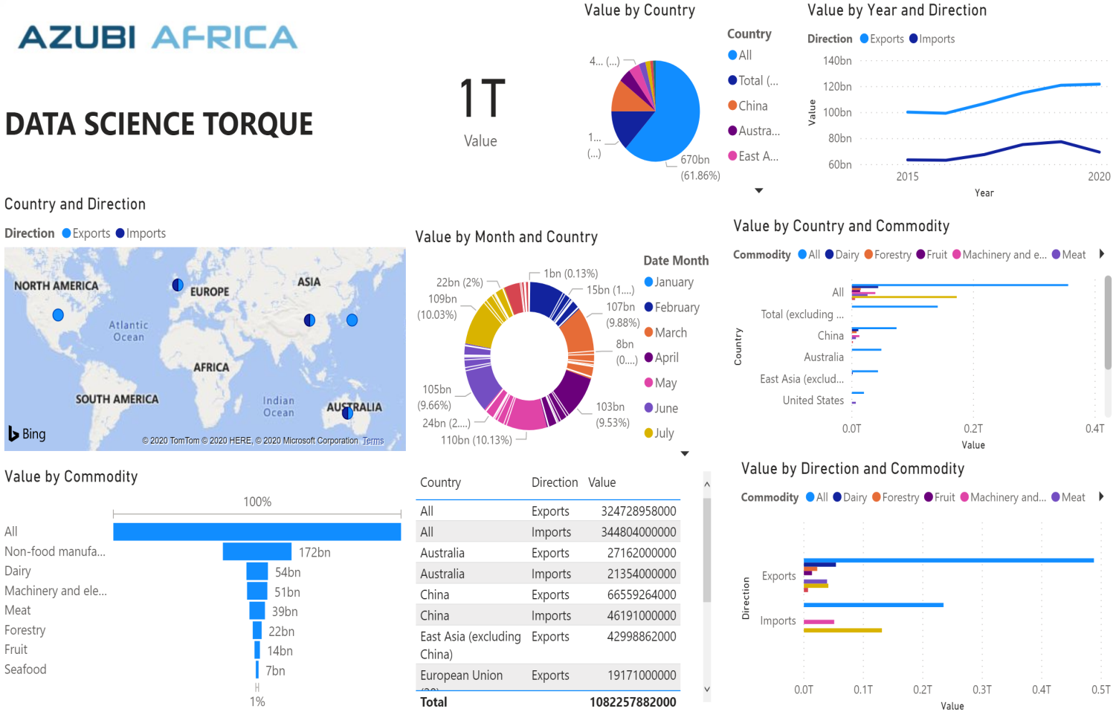

**Figure 2: Visualization of imports and exports in New Zealand**

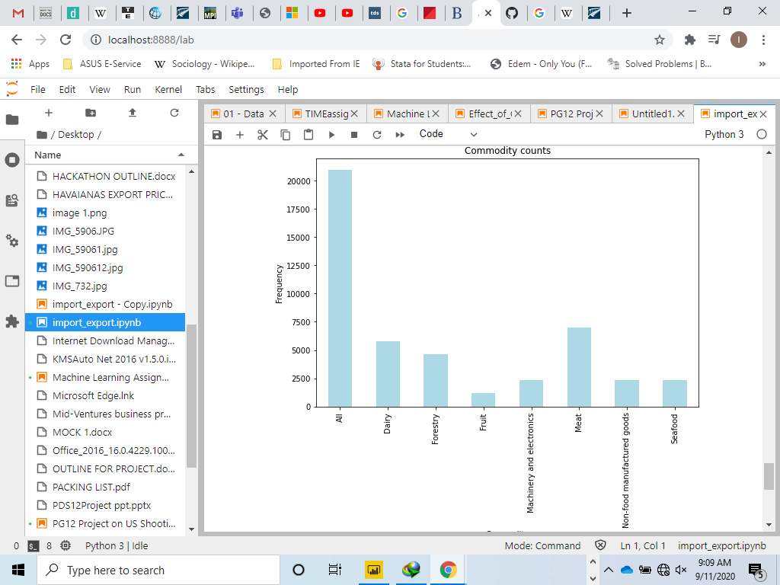

**Figure 3: Visualization of imports and exports in New Zealand**

# **CHAPTER 5**

# **CONCLUSION AND RECOMMENDATIONS**

## **4.1 Conclusion**

From the analysis and visualization that were generated, it was realized that despite the restrictions in movement of people and goods, New Zealand did fairly well in dealing with the spread of the virus. However, trade was somehow affected as there was a decline in trading activities. This could be as a result of partner countries been severely affected by the COVID-19 pandemic or as a result of the closure of boarders in order to contained and stop the spread of the disease.

This however gives an insight that New Zealand could look out to strengthen their ties with countries which were also able to contained and avoid the spread of the virus so as to increase their trades. One of such countries that we will recommend is Ghana. Looking at the ratio of affected people, the recoveries and the deaths recorded which put them in a good position to open up their borders to go back to normalcy.

## **4.2 Recommended Solutions**

* Flight cancellations by airlines affected airfreight shipments.  The Government with the aviation sector could help ensure New Zealand’s key airfreight services remain open for critical imports and exports, including food.
* The New Zealand Trade and Enterprise (NZTE) could support the coordination of some additional flights to deliver freight capacity. Exporters and freight forwarders interested in using this capacity should visit the NZTE website for up to date information on the initiative.
* The Treasury's New Zealand Export Credit (NZEC) may be able to provide support for exporters experiencing difficulties resulting from COVID-19. Trade credit insurance protects a business from losses arising from unpaid invoices, including as a result of a buyer’s bankruptcy. NZEC's ‘top-up cover’ arrangements provide additional cover to ensure that New Zealand exporters and their integral domestic suppliers can trade with confidence.

# **REFERENCES**

|  |  |
| --- | --- |
| [1] | K. Birla, "World is not flat: slowbalisation will define the decade," 17 May 2020. [Online]. Available: https://www.business-standard.com/article/companies/world-is-not-flat-slowbalisation-will-define-the-decade-says-k-m-birla-120011401406_1.html.. |
| [2] | J. H., "Could coronavirus bring about the 'waning of globalization’?," 17 May 2020. [Online]. Available: https://www.weforum.org/agenda/2020/03/globalization-coronavirus-covid19-epidemic-change-economic-political. |
| [3] | F. Richter, "The COVID-19 economy: does it mean the end of globalization?," [Online]. Available: https://www.weforum.org/agenda/2020/05/globalisation-covid19-gdp-drop-2008-financial-crisis/. |
| [4] | W. T. Organization, "COVID-19 and world trade," 2020. [Online]. Available: https://www.wto.org/english/tratop_e/covid19_e/covid19_e.htm. |
| [5] | W. H. Organization, "Q&A on Coronaviruses (COVID-19)," WHO , 17 April 2020. [Online]. Available: https://www.who.int/emergencies/diseases/novel-coronavirus-2019/question-and-answers-hub/q-a-detail/q-a-coronaviruses. |
| [6] | M. f. P. Industries, "COVID-19 and the effects on Trade," 30 June 2020. [Online]. Available: https://www.mpi.govt.nz/exporting/coronavirus-and-the-effects-on-trade/. |
| [7] | C. C, Problem Solving: A Statistician's Guide, Chapman and Hall, 1995. |
| [8] | C. R, P. M and P. A., "Detecting moving objects, ghosts, and shadows in video streams.," IEEE Trans Pattern Anal Mach Intell. , 2013. |
| [9] | S. Y and S. M., "Bayesian modeling of dynamic scenes for object detection," IEEE Trans Pattern Anal Mach Intell. , 2005. |